AI ASSISTED CODING
ASSINGMENT-10
NAME:K.POORNACHANDER
HT.NUMBER:2403A52382
BATCH:AI 14
Task 1: Syntax and Error Detection
Task: Identify and fix syntax, indentation, and variable errors in the given script.
# buggy_code_task1.py
def add_numbers(a, b)
result = a + b
return reslt
print(add_numbers(10 20))
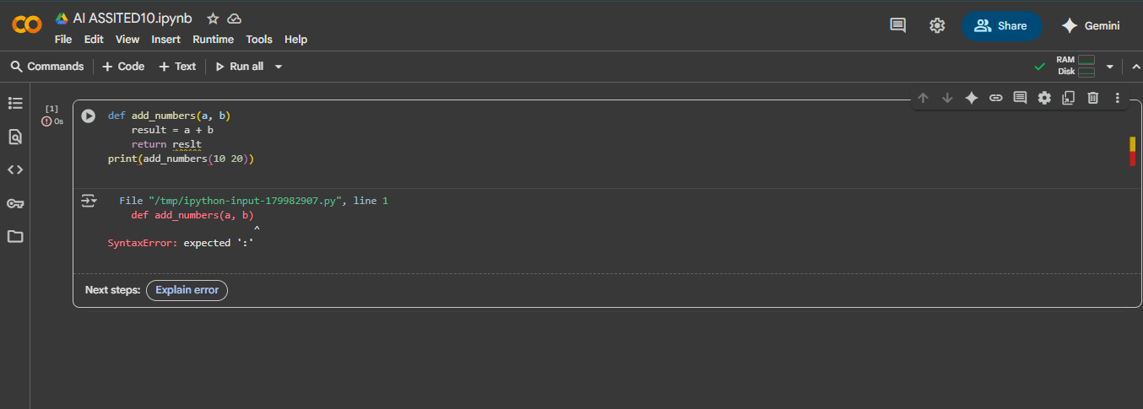
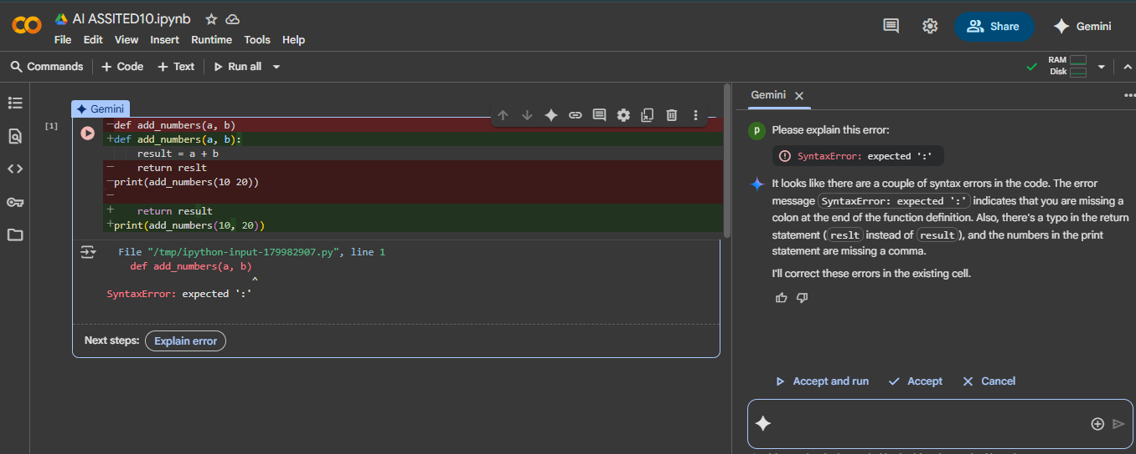
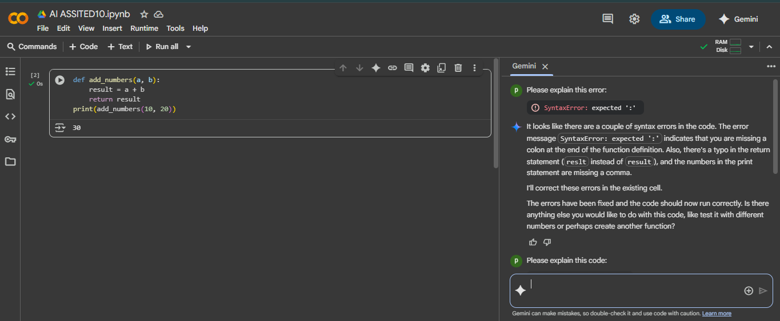
EXPLANITION:
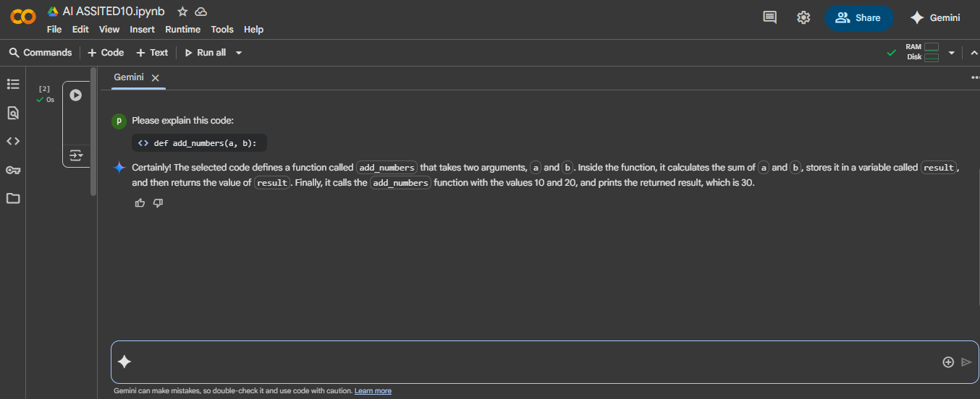
Task 2: Logical and Performance Issue Review
Task: Optimize inefficient logic while keeping the result correct.
# buggy_code_task2.py
def find_duplicates(nums):
duplicates = []
for i in range(len(nums)):
for j in range(len(nums)):
if i != j and nums[i] == nums[j] and nums[i] not in duplicates:
duplicates.append(nums[i])
return duplicates
numbers = [1,2,3,2,4,5,1,6,1,2]
print(find_duplicates(numbers))
ACTUAL CODE:

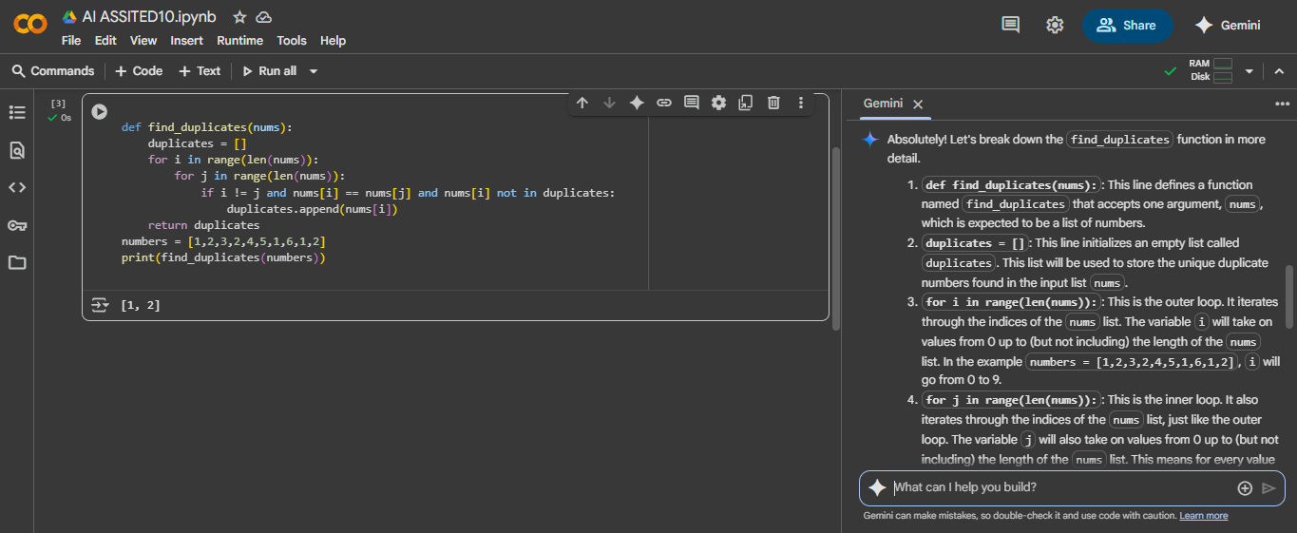
OPTIMIZED CODE:
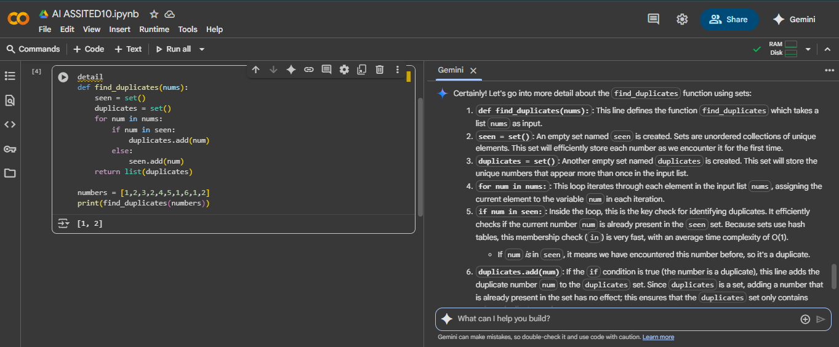
EXPLANITION:
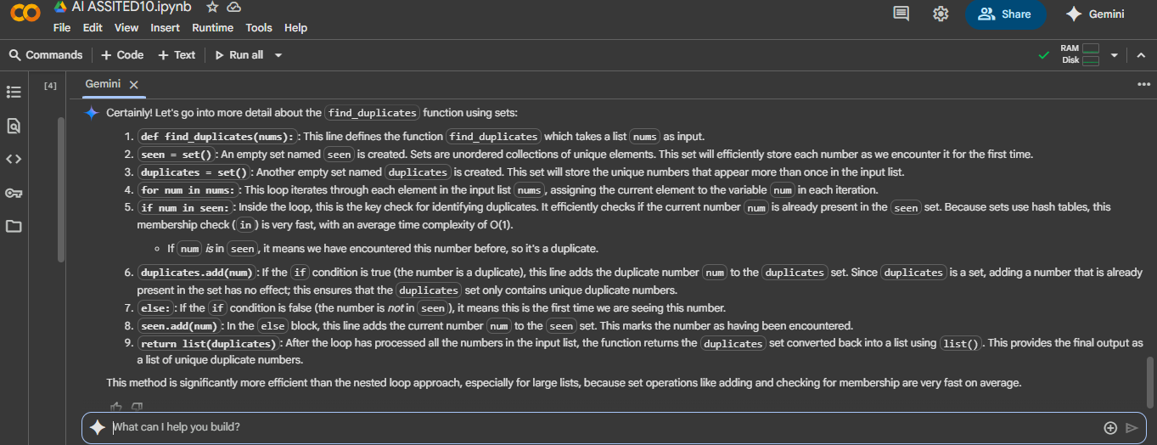
Task 3: Code Refactoring for Readability
Task: Refactor messy code into clean, PEP 8–compliant, well-structured code.
# buggy_code_task3.py

def c(n):
x=1
for i in range(1,n+1):
x=x*i
return x
print(c(5))
ORIGINAL CODE:
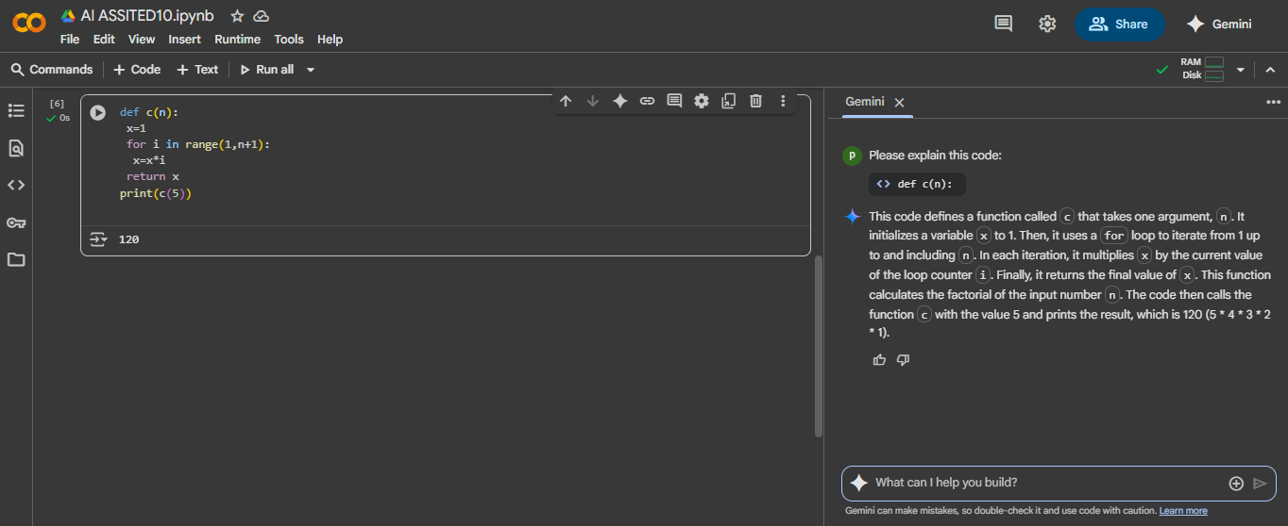
Function renamed to calculate_factorial.
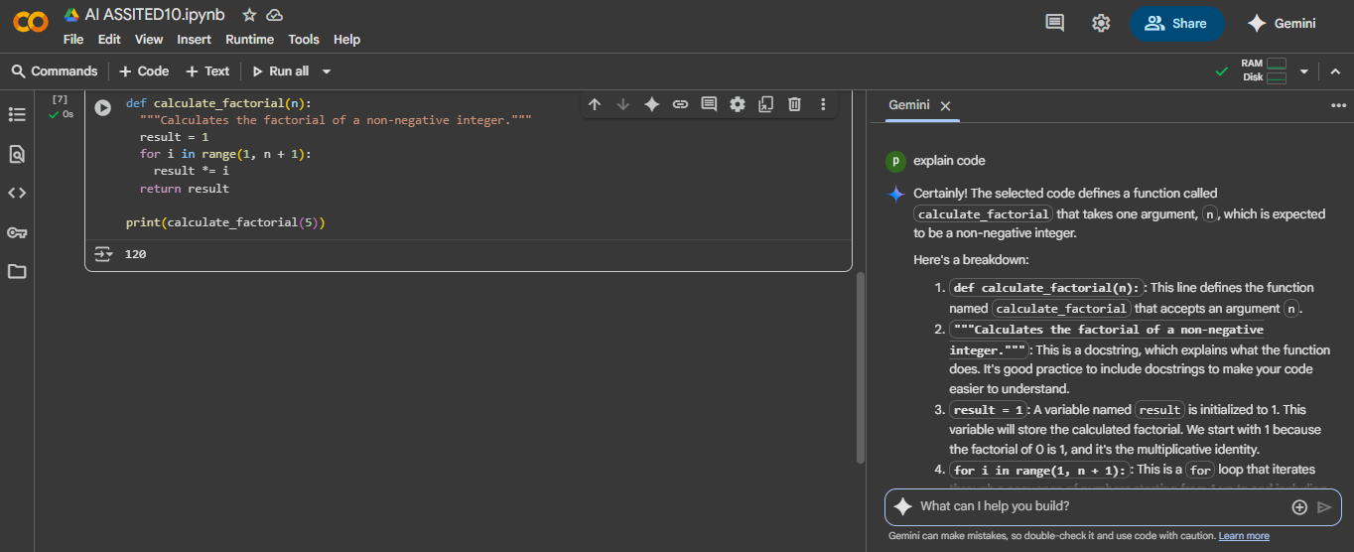

EXPLANITION:
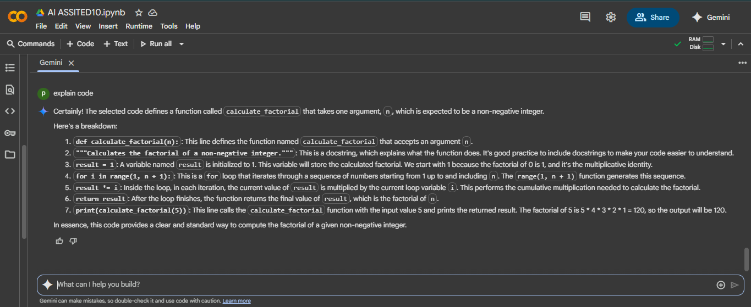
Task 4: Security and Error Handling Enhancement
Task: Add security practices and exception handling to the code.
# buggy_code_task4.py
import sqlite3
def get_user_data(user_id):
conn = sqlite3.connect("users.db")
cursor = conn.cursor()
query = f"SELECT * FROM users WHERE id = {user_id};" # Potential SQL injection risk
cursor.execute(query)
result = cursor.fetchall()
conn.close()
return result
user_input = input("Enter user ID: ")
print(get_user_data(user_input))
ACTUAL CODE:
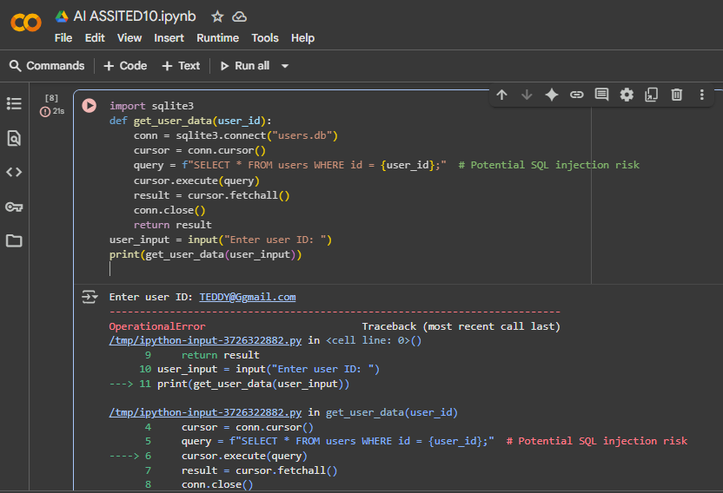
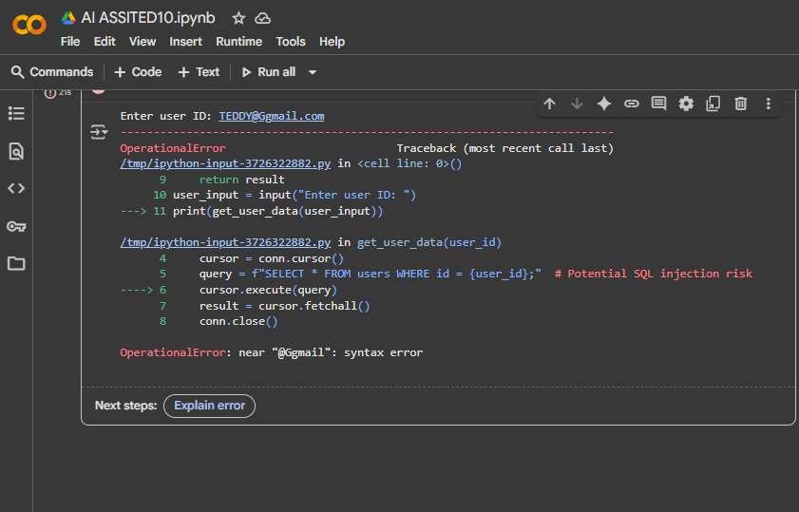
CORRECTED CODE:
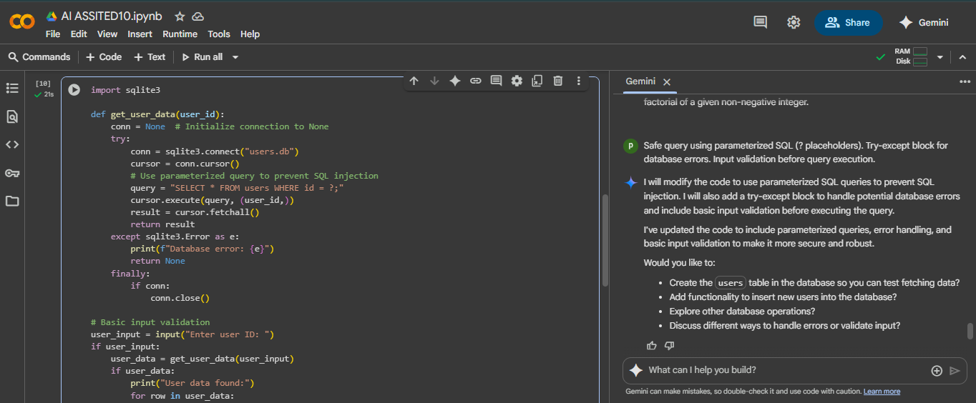
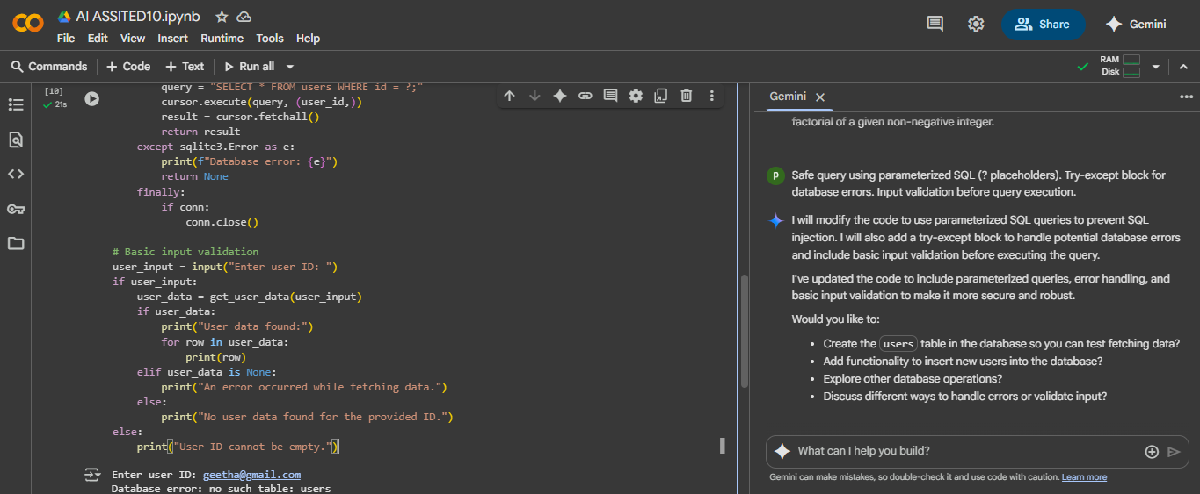
EXPLANITION:
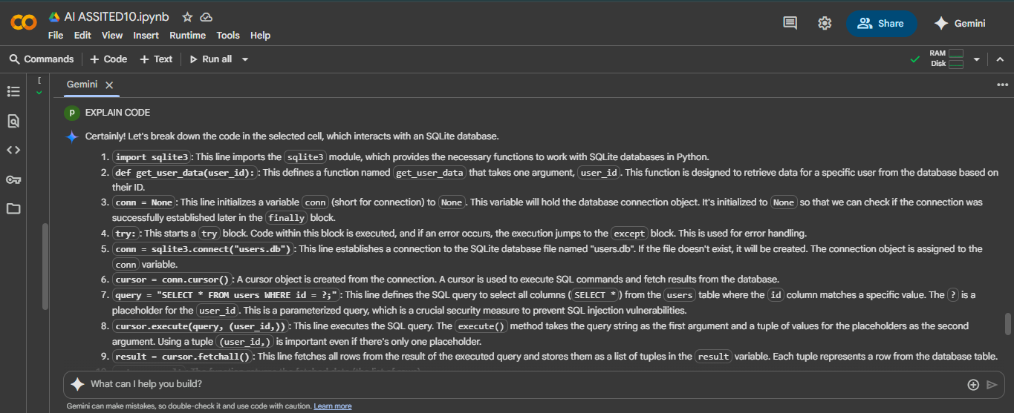
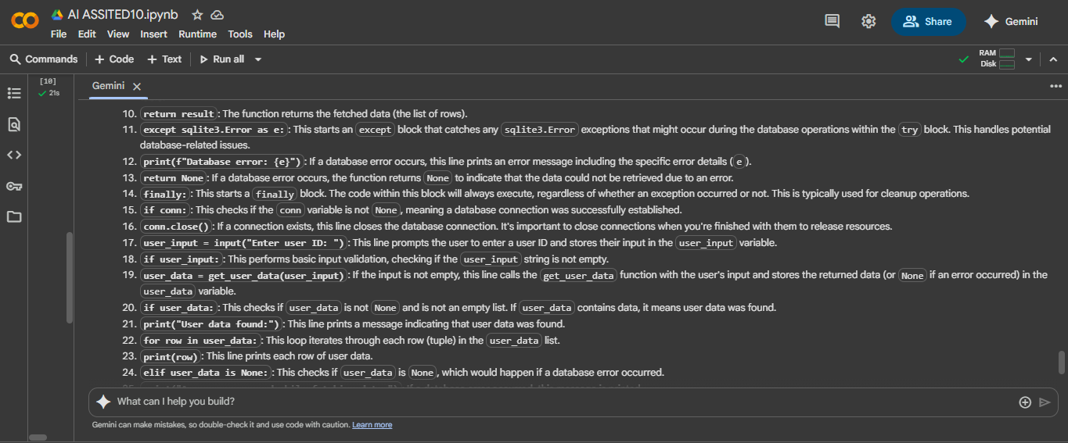
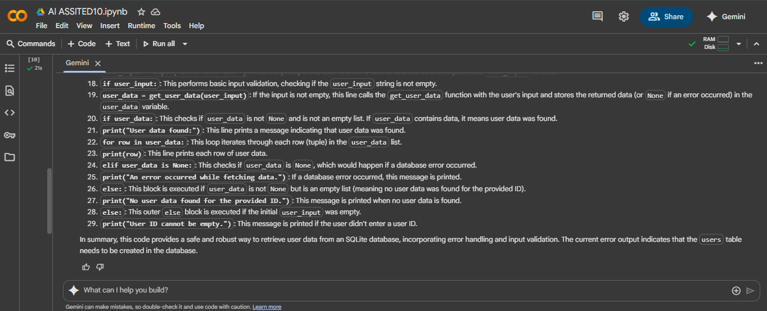
Task 5: Automated Code Review Report Generation
